**Quick Overview:**

Well done! You’re on our shortlist :)

I was impressed with our call and am looking forward to seeing what you can do here!

Below is a series of short tasks that we would like you to complete, these represent a cross-section of the tasks and projects you will be required to do (but it’s definitely not going to be limited to these - we have a list!)

Please complete the tasks below to the best of your ability, how you do them is up to you - there is A LOT here to do, and you do not need to complete all of it (if you do that is great though).

You have up to 2 hours (paid) to complete as many of these activities as you can - when you get the activities completed, please let me know how long it took you.

IMPORTANT: DO NOT GO OVER THE 2 HOURS FOR THIS PAID TRIAL. The purpose of the time limit is to create ‘time pressure’ in order to help us gauge how you actually perform with it.

The sooner you can do these the better as we’re looking to start someone ASAP

Please click on File > Make a Copy to get an editable version of this document to submit

Thanks and looking forward to seeing how you go!

**Facebook Comments:**

Here are some examples of comments on some of our client Facebook Ad Campaigns.

Can you please respond with what you would reply with in each situation (this can include deleting / hiding) and also what you would ask from us or the client in answer to some of these questions:

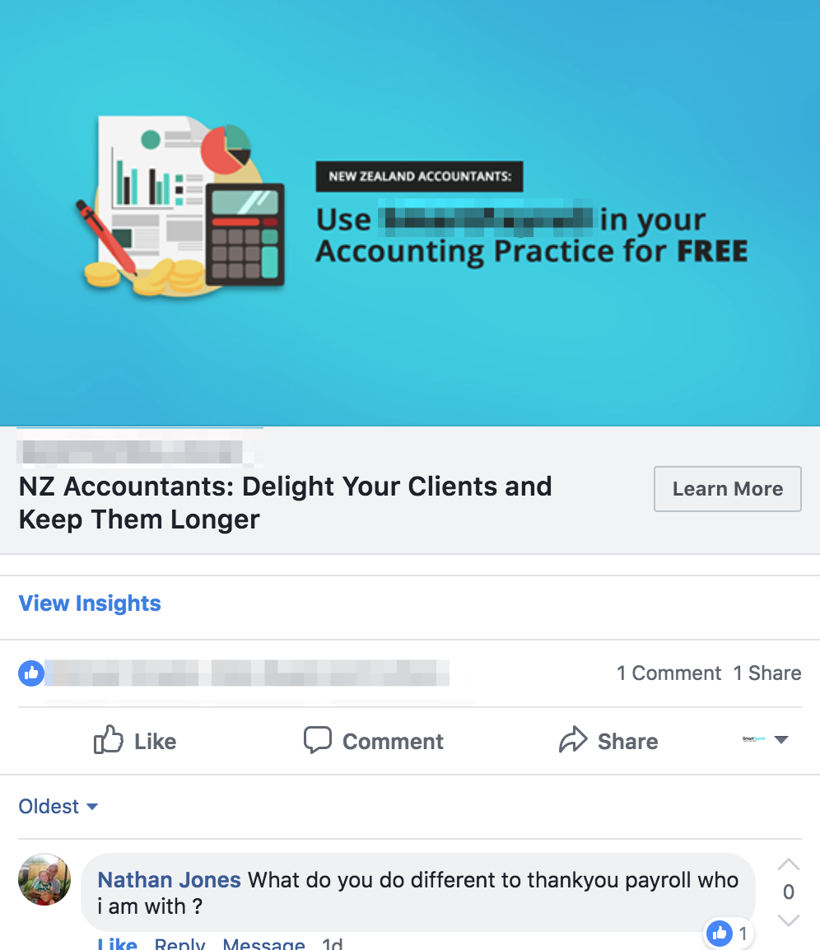

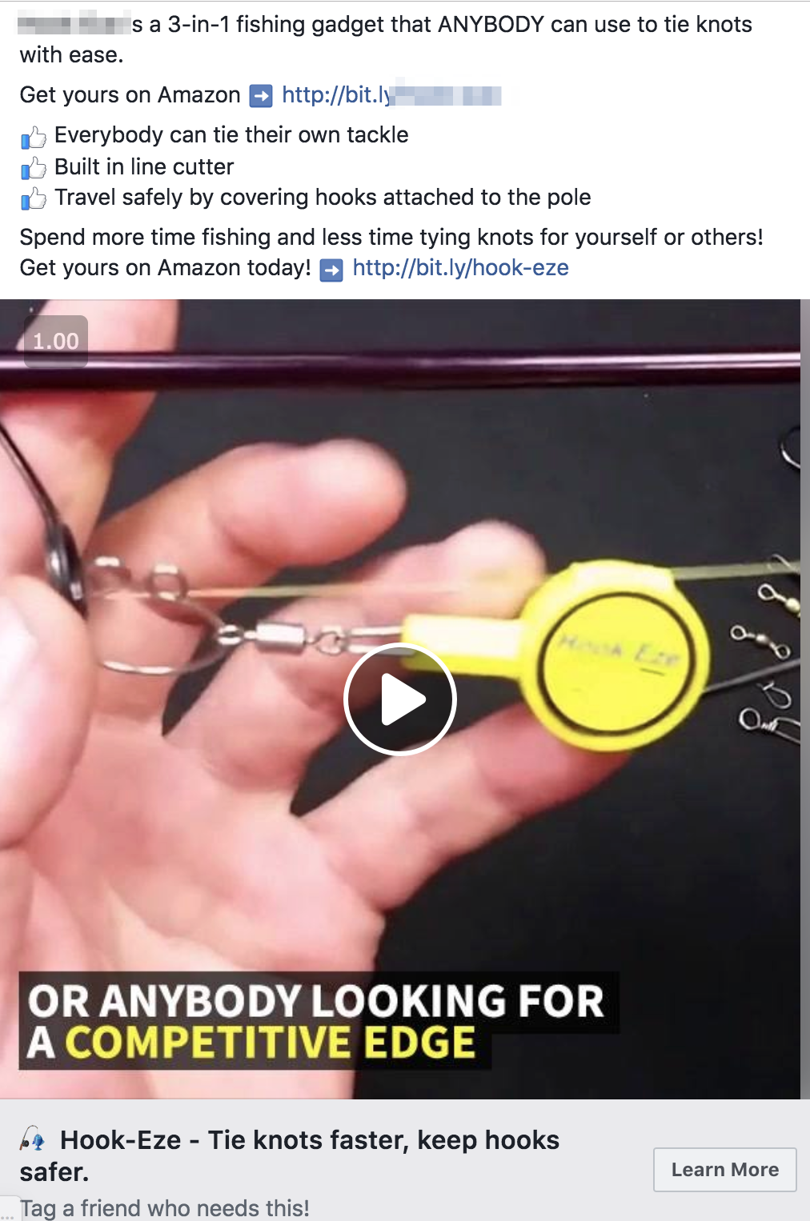 (The comments for this ad are below)

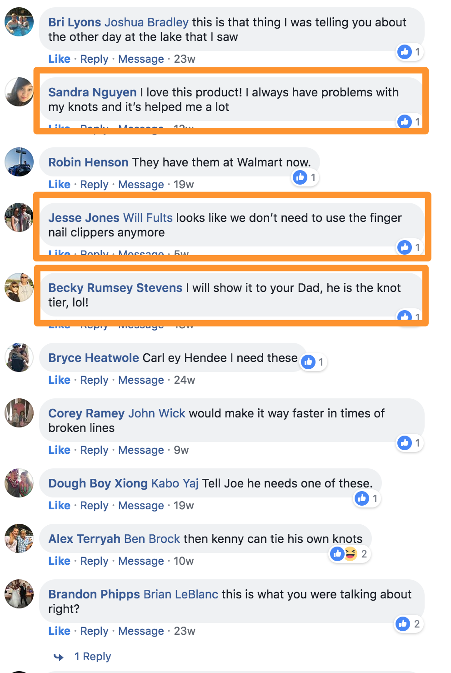

The following comments are about some live workshops that a client was doing around the country here in Australia:

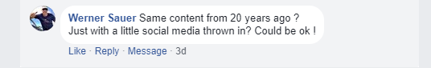

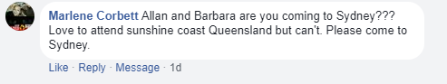

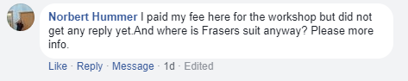

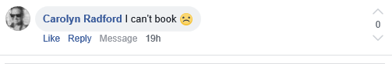

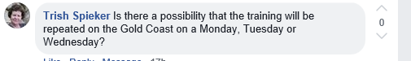

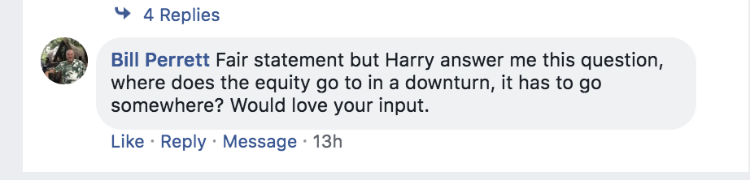

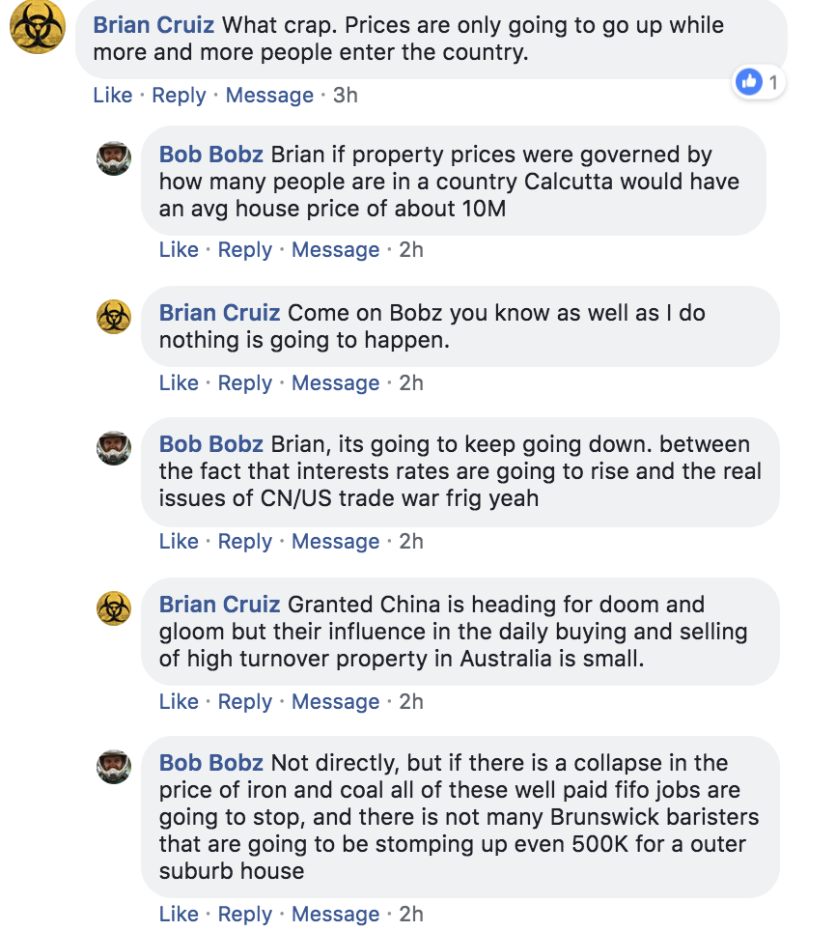

**Fill in our ‘Campaign Dashboard’ Spreadsheet**

One of the main tasks you will be doing is filling in campaign results on a daily basis in this spreadsheet

Please use the screenshots provided to fill in the numbers for the spreadsheet (from June 24th)

When doing this, please click on ‘File’ > ‘Make a Copy’ to create an editable version for you. Please name it YOUR NAME AD Campaign Dashboard when sending it back to us

Link to Document: [REMOVED FOR IP PROTECTION -INSERT LINK TO ANY OF YOUR OWN RESOURCES IF REQUIRED]

CLIENT 1

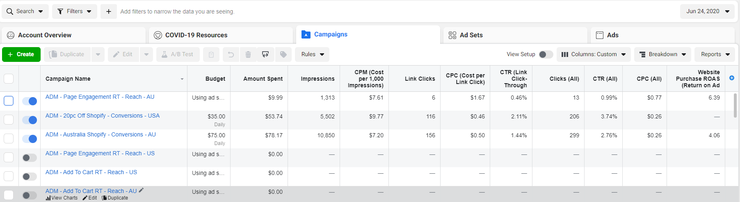

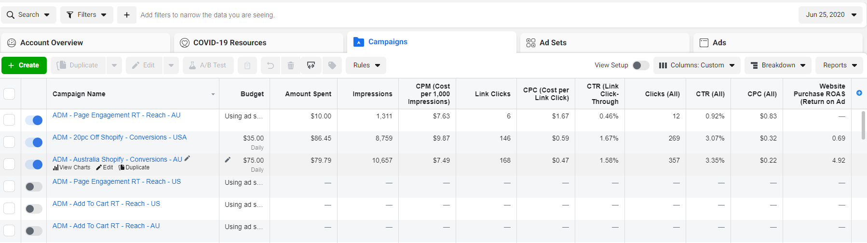

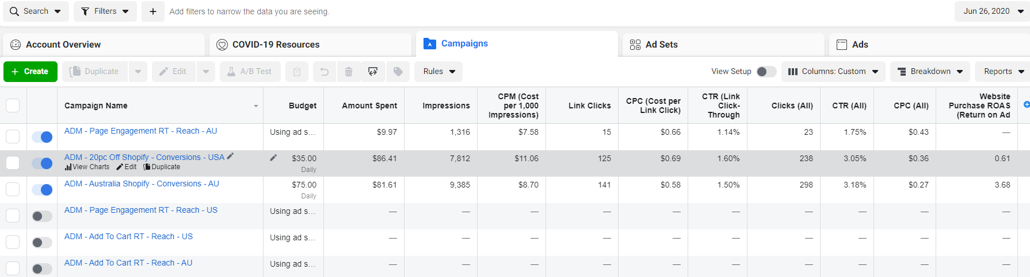

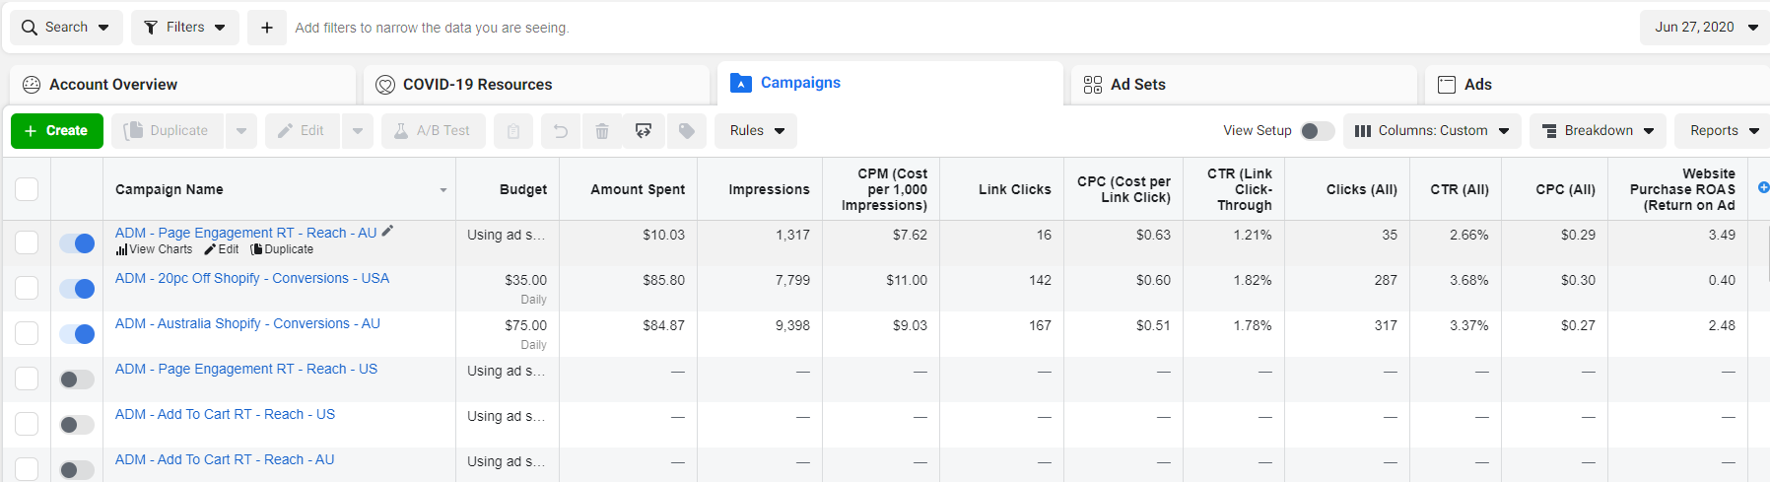

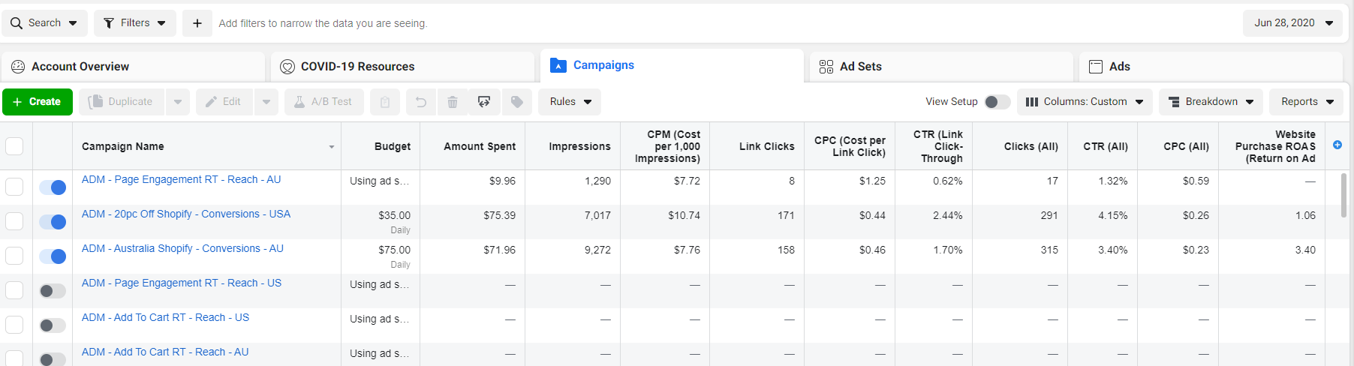

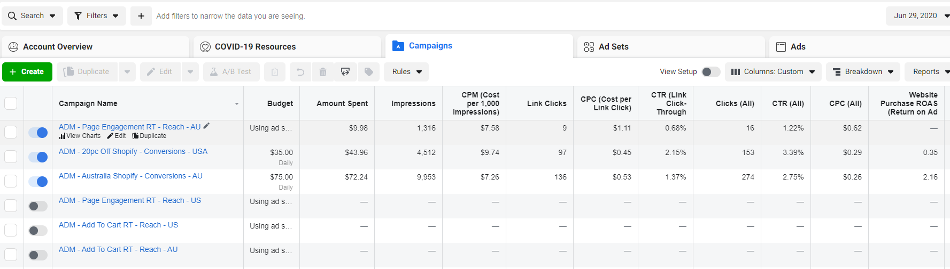

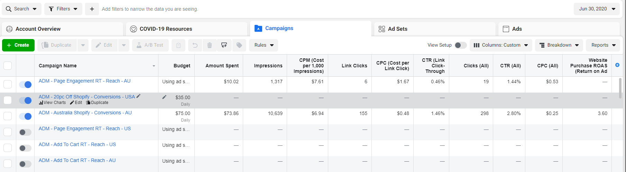

CLIENT 2

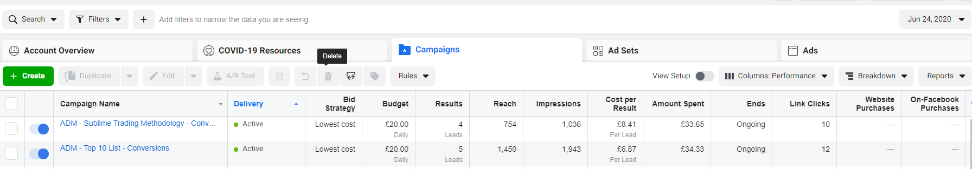

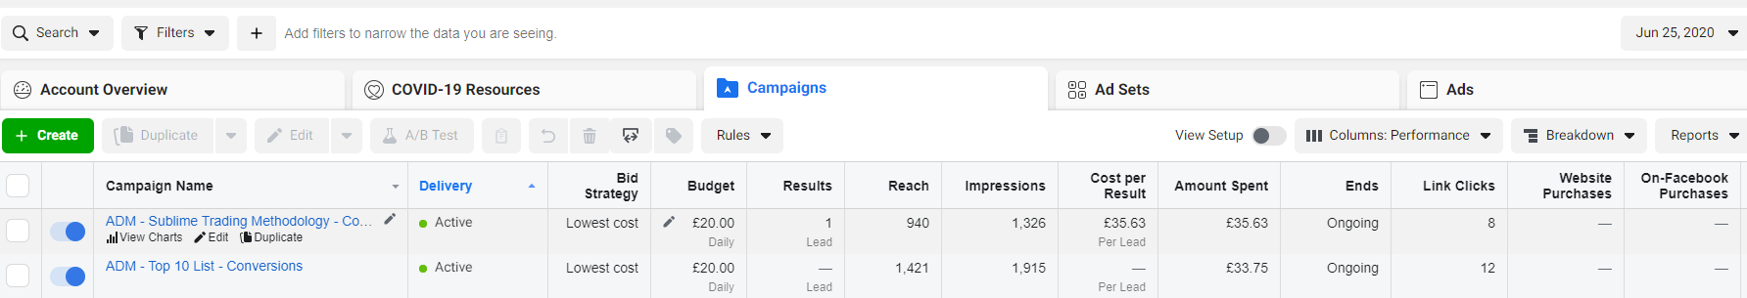

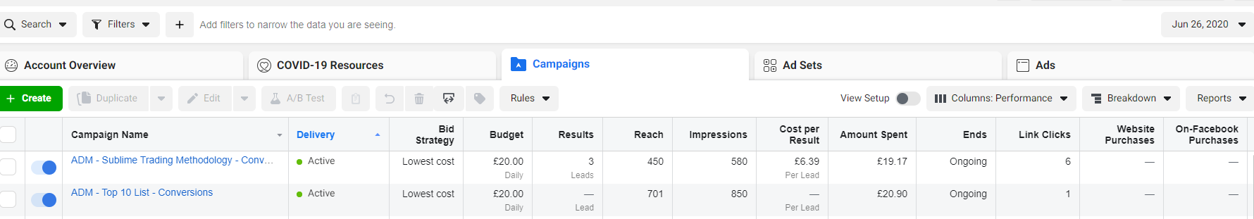

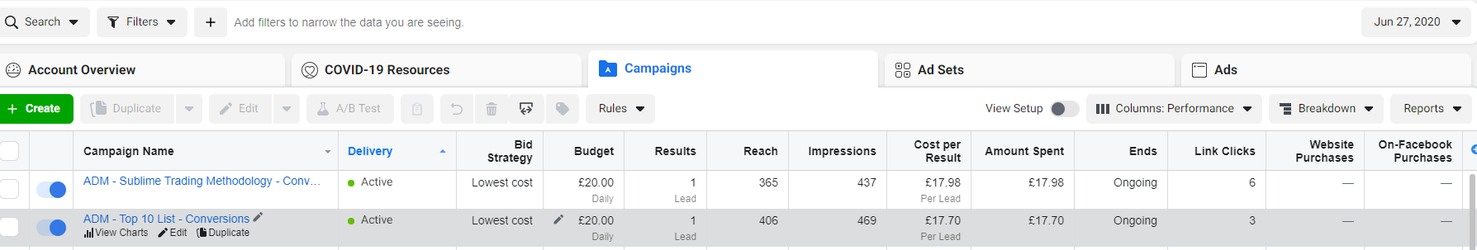

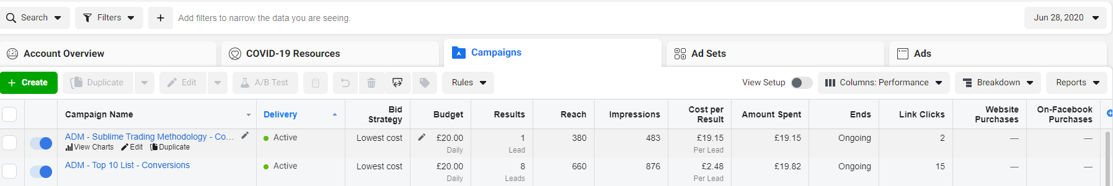

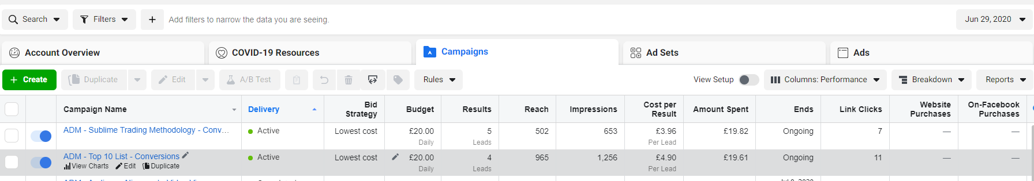

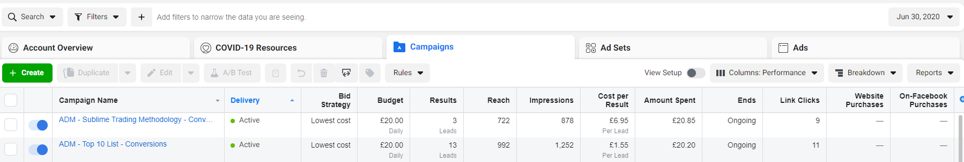

CLIENT 3

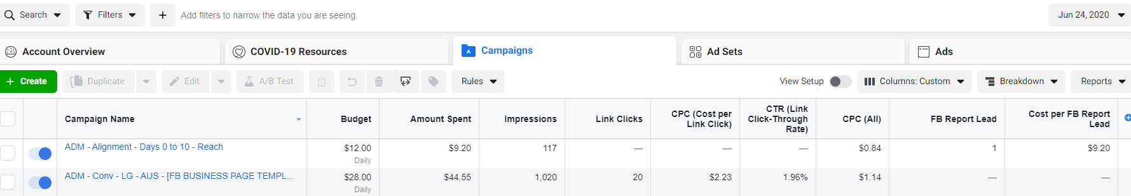

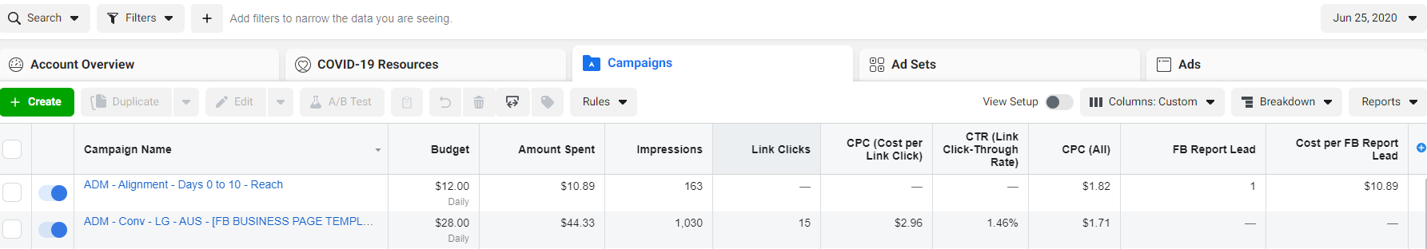

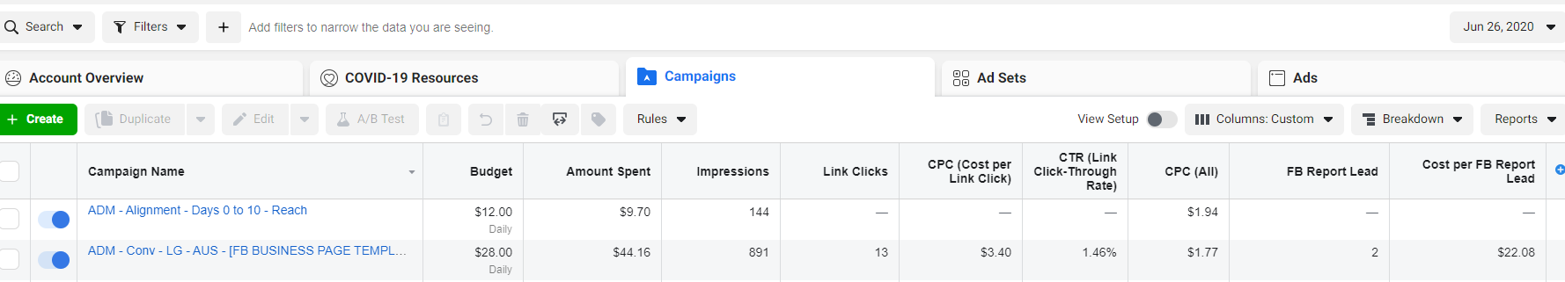

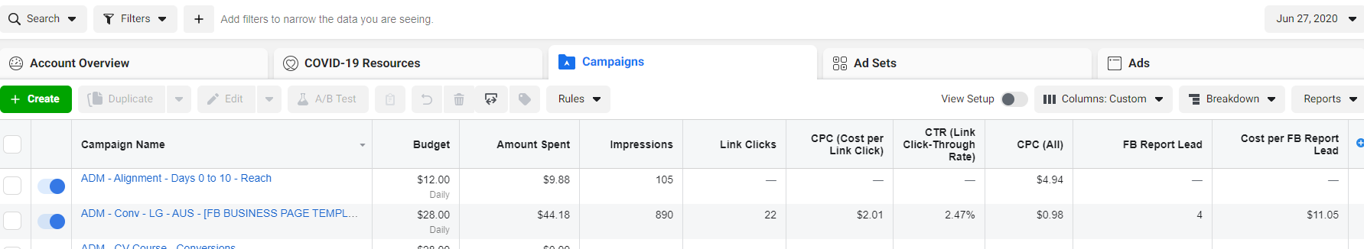

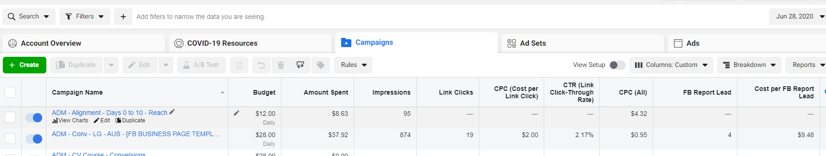

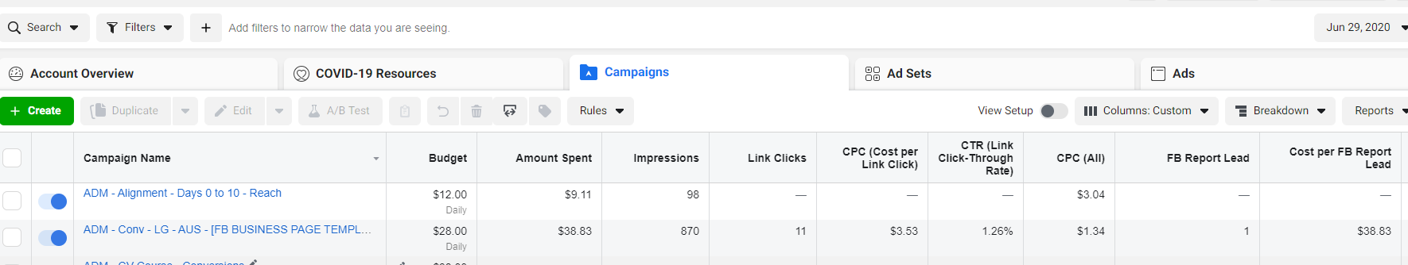

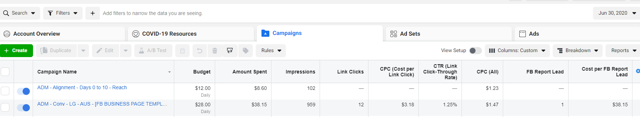

**Create Youtube Post from Video Content**

One of the things we need to get much more consistent with is our content going to our socials (FB page, FB group, Insta, Linkedin and Youtube)

During busy times (like it has been currently), it is difficult for me to create dedicated pieces of content (specifically video)

Another main task you will be responsible for is posting content that is provided to social platforms - Facebook, Instagram, Youtube and Linkedin

I would like you to choose between any of the following videos and create a Youtube upload from this (upload to your own channel but make it ‘Unlisted’).

When uploading, please write a Video Title, Description, Tags as a minimum. BONUS if you can also do a thumbnail for it

Send me the link to the video when it is uploaded so I can check the above

NOTE: Usually video titles and descriptions will be provided - but in this case please do the best you can with this

Video 1: [REMOVED FOR IP PROTECTION -INSERT LINK TO ANY OF YOUR OWN RESOURCES IF REQUIRED]

Video 2: [REMOVED FOR IP PROTECTION -INSERT LINK TO ANY OF YOUR OWN RESOURCES IF REQUIRED]

VIdeo 3: [REMOVED FOR IP PROTECTION -INSERT LINK TO ANY OF YOUR OWN RESOURCES IF REQUIRED]

**Fill in our ‘Alignment Grid’**

Another task you will be doing is filling out our ‘Alignment Grid’

This spreadsheet enables us to see what content we request from the client is engaging and what isn’t

I know you aren’t fully trained on how to fill this out, so please do the best you can.

What needs to happen for this is:

* Go to this Facebook Page: REMOVED FOR CLIENT PRIVACY
* Go back to the post on April 1st (it is ‘Going live tomorrow friends’)
* Look at how this post has been entered into the Alignment Grid (link below)
* Please fill in the Alignment Grid for every post from April 1st (sort the posts from oldest at the bottom to newest at the top)

When filling the table out:

* Enter the date the post was published
* Select the channel (eg Facebook Page, Facebook Group)
* Copy and paste the first sentence of the post into column C and then link that to the actual post on Facebook
* Enter in how many comments and likes it has (if any)
* Describe the post type in the ‘Medium’ column. For example does it have long or short form text, is it an image or video
* Provide an Engagement ranking using our legend in Column J and K

When doing this, please click on ‘File’ > ‘Make a Copy’ to create an editable version for you. Please name it YOUR NAME ADM Alignment Grid

Link to Document: [REMOVED FOR IP PROTECTION -INSERT LINK TO ANY OF YOUR OWN RESOURCES IF REQUIRED]

**Collect Information for our Monthly Reports**

Each month we send a report to our clients that shows performance of key metrics and provides a summary of our thoughts on it all.

We will be getting you to collect the numbers for the report so Kirsty on our team can put the reports together and send to the clients.

I’ve included a screenshot of the report being prepared below (next page) so you can see most of what is sent across.

For this task:

* Please look at the screenshot of the ad account provided
* Collect and provide the numbers in the four main sections from ‘Performance Summary’ (Awareness, Consideration, Conversion, Financials) in a clean and easy to follow format (can be a document or spreadsheet)
* Imagine that you are sending this to Kirsty (along with several other client results) for her to create the reports and send to our clients

